Point clipping

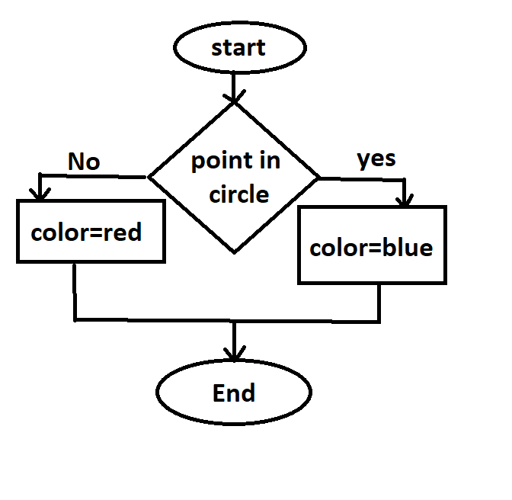

Curve used: Bezier curve

Circle used: Bresenham circle

Clipping used: point clipping